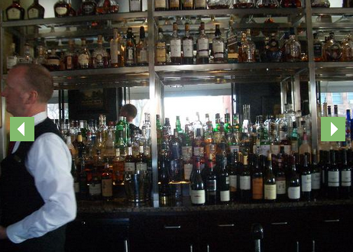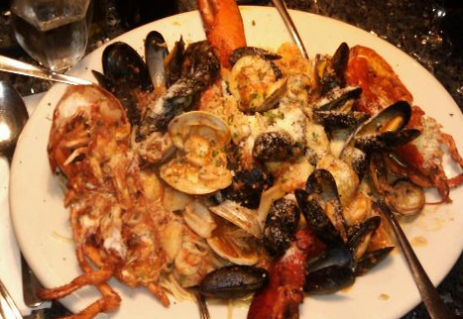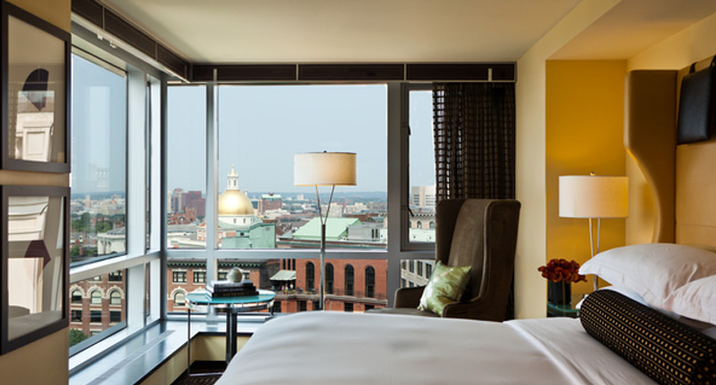 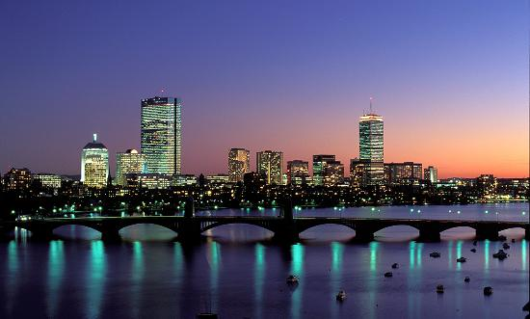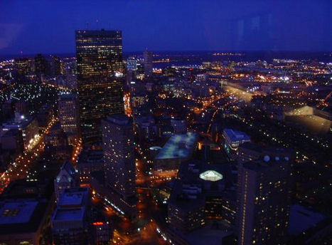

I found a restaurant that could fit my family. The Capitol Grill is a very old fashioned restaurant and mom would love that. They also have a wine bar that mom and dad would like to sit at. Abi would like the shrimp cocktail because she loves shrimp. I would like the stack and Jenna would like the desert

November 22, 2013

Jet Blue Flight: 56

Departs Dulles: 9:47a

Arrives Boston: 11:11

November 24, 2013

Jet Blue Flight 1257

Departs Boston: 6:27am

Arrives Dulles: 8:11am

Total Cost of Flight for 5 people: 2,165

Flight Information

November 22-24, 2013

I would like to go to Boston because I have never been to Boston. We could stay at the Nine Zero hotel. They have a flat screen TV and they let you have pets. They also have a gem and a nice cafeteria

# The Capitol Grill

#### Nine Zero Hotel

# Tanner Get Away

**Boston, Massachusetts**

Skywalk Observatory view of Boston at night

#### Activities

Franklin Park Zoo: Tiger

# Franklin Park Zoo

Remember when Mawmaw sang Happy Birthday to you Mom? You said “I live in a zoo, and have 3 monkeys and a big gorilla too.” I would like to go to the Franklin park zoo because Jenna would like the Graf I would like tiger and dad would like the gorilla.

Tiger at Franklin Park Zoo

# Duck Boat

My whole family would like the duck boat. The boat is only three dollars. All of us would like to see the New England Aquarium. We can ride the boat to the Aquarium. This is a special boat because it can go in water and on land!