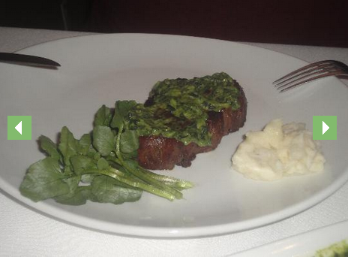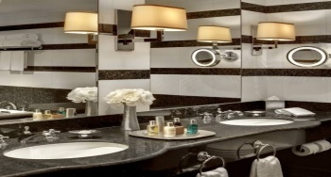

November 22, 2013

Jet Blue Flight: 56

Departs Dulles: 9:47a

Arrives Boston: 11:11a

November 24, 2013

Jet Blue Flight 1257

Departs Boston: 6:35p

Arrives Dulles: 8:16p

Total Cost of Flight for 9 people: $3330

Flight Information

November 22-24, 2013

Dad! You and I should go to Desmond steakhouse because we both love steak so much. Their food is so fancy and their food is set up so well. Also when we are done eating steak, they have cheesecake. They have lobster too, and me and you love lobster also.

Mom and dad come here! We should go to New York to the Towers at the New York Palace. You can see the skyline out of some of the windows. That’s what we have always wanted to see. Plus at the hotel they have a fabulous bathroom. They give you mints and candy that they leave for you in a dish. Mom and dad listen, the beds have pillows that have feathers in them and the beds are so soft.

# Desmond Steakhouse

# Rylee’s Family Get Away

**New York**

#### Towers at the New York Palace



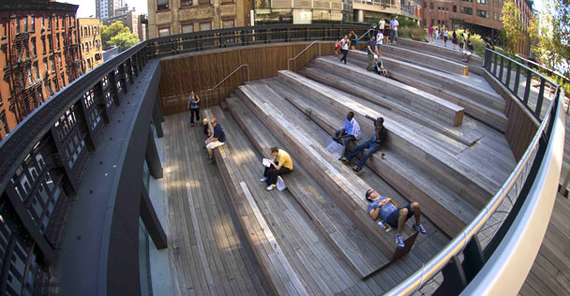

# Jersey Boys

Hey Mom, Dad, and Mamaw, remember I always wanted to dance? It was a winner of 2006 Tony Awards winner for best musical. I love when there are musicals while they are singing.

# St. Paul’s Chapel

Our family should go to the St. Paul’s Chapel because some of my family would love to go there like me, my aunt, and my grandmother. It is also a very old, old church. We can also walk there because it is so close. Also it is open all day so when we are done doing the stuff we want to do we can go to the St. Paul’s Chapel.

# Newsies The Musical

Mom, dad, grandma listen, don’t we all love musicals? If you guys do, we should go to Newsies the Musical. It is made by Disney. We all love Disney and they are the winners of the 2012 Tony awards for the best score and choreography.

# High Line

Grandma, we can go to New York because our family wants to see the Highline. It is made out of railroad tracks and rebuilt so you can walk on it. It is also a great place after we’re done eating we can just relax and unwind.

# American Museum of Natural History

Our family loves to go to museums. You can go inside and actually touch things. They have butterflies that we have never seen. They have a Museum that I’ve always wanted to go to.

#### Activities