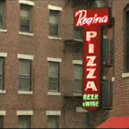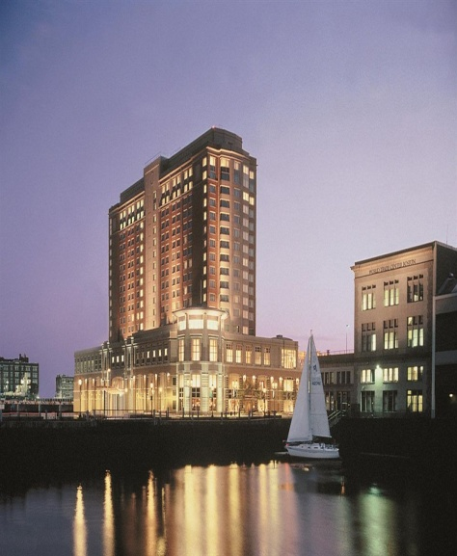 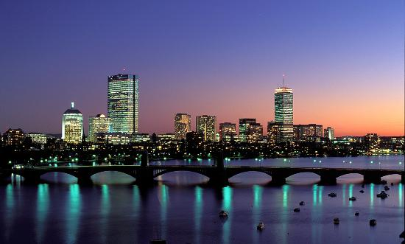

November 22, 2013

Jet Blue Flight: 56

Departs Dulles: 9:47am

Arrives Boston: 11:11am

November 24, 2013

Jet Blue Flight: 117\1407

Departs Boston: 12:10pm

Arrives Dulles: 7:00pm

Total Cost of Flight for 5 people: $3,103.50

Flight Information

November 22-24, 2013

In Pizzeria Regina they have pepperoni, buffalo, Hawaiian, sausage, and cheese pizza (I know we all love at least one of those.)They have different sizes, small and large. Now that sounds really good.

In the Seaport Boston Hotel they have an indoor pool. They also have luxury beds. It has a very nice view of the ocean. There are granite countertops. Now that is a nice hotel.

# Pizzeria Regina

#### Seaport Boston Hotel

# Walker Family Get Away

**Boston, Massachusetts**

# Simon’s IMAX theatre at New England Aquarium

Since we like the theater I think we could go. This is a nice place for us to see movies. I think that this is perfect for our family because we like to see movies. This is where I think we should go for our trip.

# Paul Revere House

By the Paul Revere House there is a statue of him on his horse. The house has an old- fashioned door. In the house we can go to his kitchen. Just outside the house is a courtyard. I think it would be nice to learn how Paul Revere lived.

#### Activities

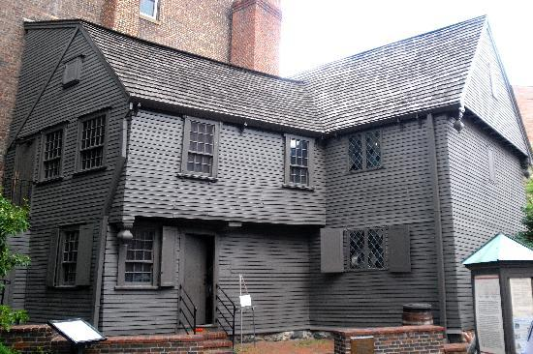

# Museum of Fine Arts

In this museum you can see all kinds of pictures. It is a nice place of art. This will be a nice trip for our family.

# Neiman Marcus

Neiman Marcus is a store with fancy stuff and lots of bright colors. In this store they have a boys section for Brandon and dad but, they have girls sections for you Laurel and mom. For you Laurel and mom, there are also flats. And Brandon, there are khakis. Then finally dad, there are shirts and ties so there are things for all of us. So let’s go there.

# Franklin Park Zoo

# At this zoo you can see animals that are really cool like lions, elephants, and zebras. Also they have a gift shop where you can buy things. This would be really cool to go and see.



The Paul Revere House