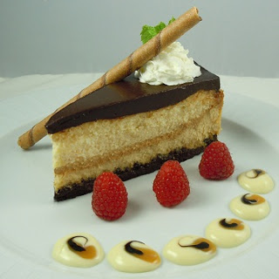
Homewood Suites by Hilton Philadelphia-King Studio Suite
Homewood Suites by Hilton Philadelphia-City Avenue Hotel Main Entrance 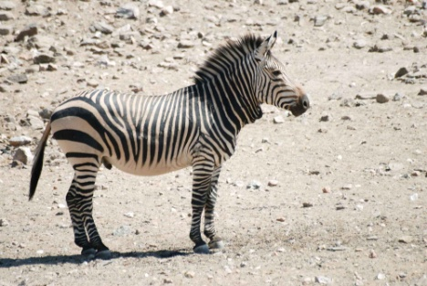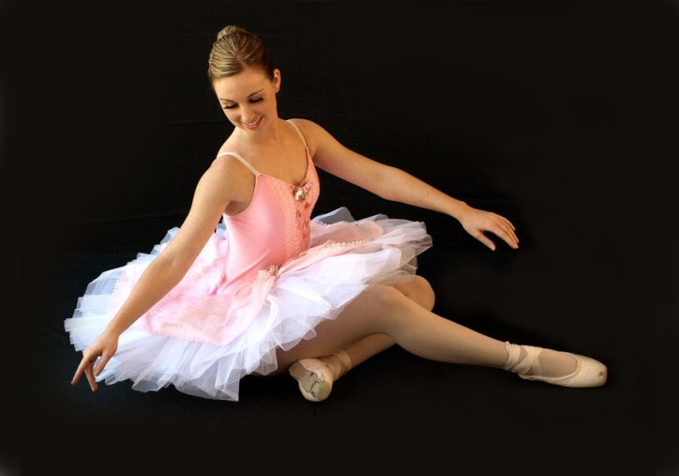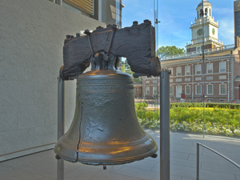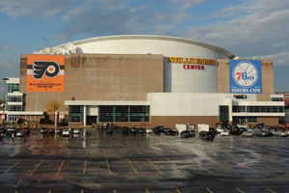

The hotel has an indoor pool. I love to swim. The hotel has a flat screen TV. I love to watch TV! It also has a snack bar. If we are going somewhere we can just grab a snack. We also can cook in our room because we have a kitchen.

# Homewood Suites Philadelphia

November 22, 2013

United Flight: 3333

Departs Dulles: 12:16pm

Arrives Philadelphia: 1:16pm

November 24, 2013

United Flight 3333

Departs Philadelphia: 1:46pm

Arrives Dulles: 2:44pm

Total Cost of Flight for 4 people: $2523

Flight Information

November 22-24, 2013

This restaurant has baby shrimp. Mom, you know how much we like shrimp. They also have steak Kyle and daddy would like steak. They might have chips and salsa!

# Paloma Mexican

# Sacre family get away

**Philadelphia, Pennsylvania**

# Philadelphia zoo

Did you know that the first zoo in America is in Philadelphia? You just have to pay $64 dollars for all of us. I want to see all the cool animals like the zebras, giraffes and elephants.

# Liberty bell

Mom Dad, I really want to go see the Liberty Bell. We can take pictures with it if they will let us. I want to see the special crack in the Liberty Bell.

Two if by sea”

# Philadelphia games

I love to play basketball. My brother also likes basketball. The 79ers are playing. They are playing against the New Orleans Pelicans.

79ers stadium wells Fargo center

#### Activities

# Firemen’s hall

If we go to the Firemen’s hall we will see stain glass. We will also see old Firemen trucks. We will learn about their tools. I hope we can go!

# Pennsylvania ballet

At the Pennsylvania ballet you will see professional ballerinas. They also do performances of the Nutcracker. I used to take ballet and it was fun.