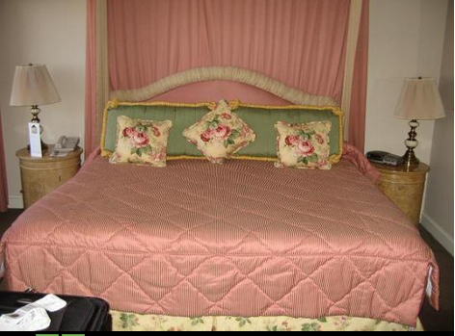 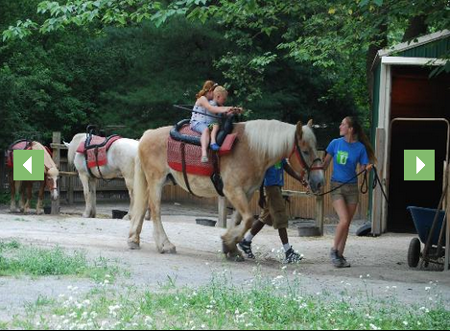

November 22, 2013

United flight: 3333

Departs Dulles:12:16pm

Arrives Philadelphia: 1:16 pm

November 24, 2013

United Flight: 3333

Departs Philadelphia: 1:46pm

Arrives Dulles: 2:44

Total Cost of Flight for 2 people: $631.80

Flight Information

November 22-24, 2013

Hip City Veg’s interior building is pretty old fashioned. And their cuisines go from noodles to hamburgers. They also have something called The Groothie which is a whole bunch of fruits and vegetables mixed together so it tastes like a smoothie. To a bunch of natural sodas. Not only that it’s really close to our hotel!

Mom, the Rittenhouse Hotel is really old, and I know that you love old houses. there is also wonderful room service but I didn’t only think about the hotel! There are all sorts of great activities nearby! Also when we get tired we can go to the hotel and see Caramel because they allow pets! But that’s not all! If you need to work on your degree you can you can do it in the wonderful business center.

# Hip City Veg

#### Ritten House Hotel

# Dowling Family Get Away

**Philadelphia, Pennsylvania**

# Independence National Historical Park

The Liberty Bell is broken and it’s here! You can see trained professionals do what the town’s people did back then! You can also see wonderful architectural buildings and scenery.

The

Horse rides at the Philadelphia zoo

# Grasso’s Magic Theatre

Grasso’s Magic Theatre was the first theatre to open in Philadelphia. I love magic performances of optical illusions and more! I thought this would be the perfect for my mom and I.

# Philadelphia Zoo

Did you ever want to feed a giraffe again? Well here you can! There are all sorts of exotic animals and really big cats! You can also go behind the scenes with a zoo care taker for only $132 a person! I know you love behind the scenes. And if that weren’t enough you can even adopt a baby animal!

#### Activities

# Kimmel Center of Performing Arts

If you like classical movies you’re in for a treat! The Kimmel Center has it all from plays to bands (some are really old school.) And to top it off they also have all sorts of dancing!

# Philadelphia museum of art

The museum has amazing, breathtaking statues and fountains! They also have amazing self-portraits and paintings!