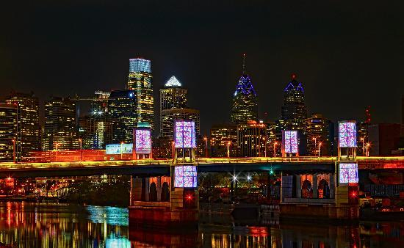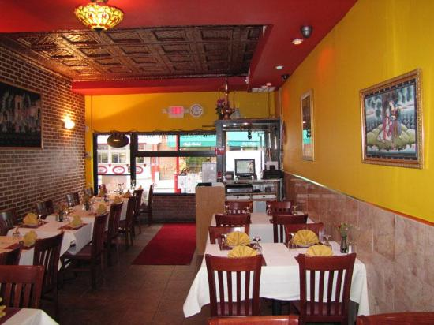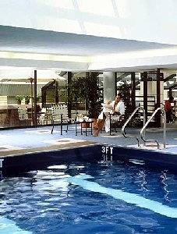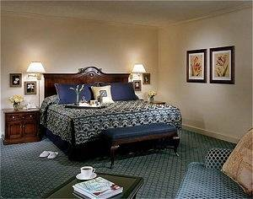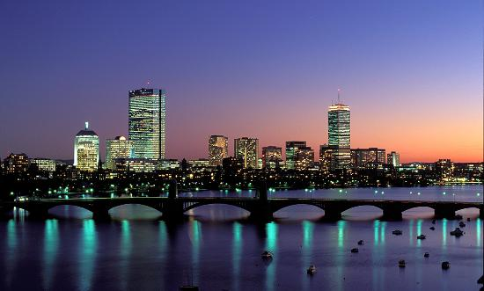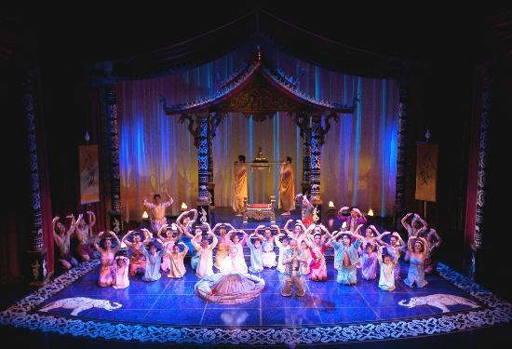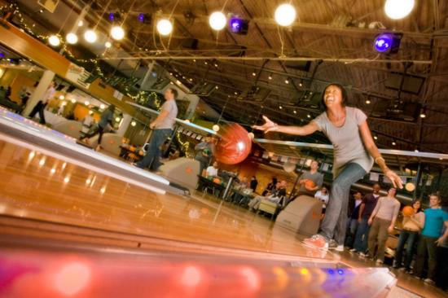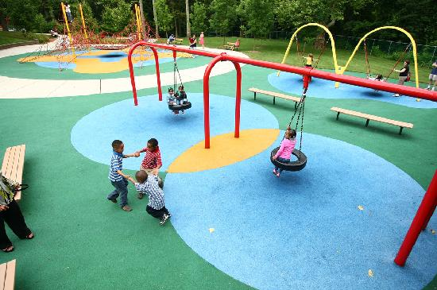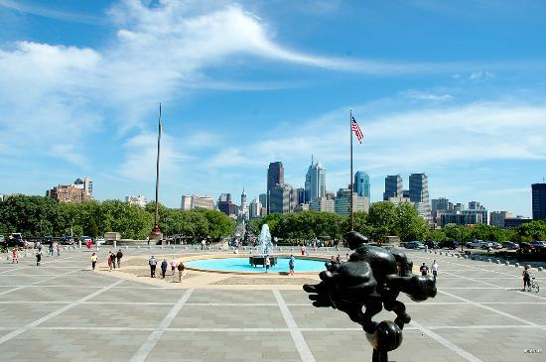

The Rittenhouse hotel is a AAA diamond award winning hotel. It has an indoor swimming pool and lots of family activities. It is near the city so if we get tired of walking we can go back to the hotel. Their food is delicious and if we don’t want to leave for breakfast, they have a breakfast buffet.

Phone: 215-222-7221

It’s located: University City

I picked Saad’s Halal place because it is rank # 7. They have sandwiches, soup and salads. It is near some little shops and it has great service.

November 22, 2013

US Airways flight 3270

Departs Dulles: 8:24

Arrives Philadelphia: 9:24 pm

November 24, 2013

Departs Boston: 6:35p

Arrives Dulles: 8:16p

Total Cost of Flight for 4 people: $631

Flight Information

November 22-24, 2013

# Saad’s Halal place

#### The Rittenhouse hotel

# Sherman’s Family Get Away

**Philadelphia,**

**Pennsylvania**

# Philadelphia Museum of art

It won travelers choice 2013 winner. It is rank # 1 out of 267 museums. This museum has some of the most famous art in America. America’s famous art tour starts at eleven o’clock.

# North bowl lounge n lanes

My family would love this because it is a family fun thing to do. We can bowl and play games.

This is the front of the museum

# Walnut street theater

We have to go to Walnut street theater there they are doing the musical Elf now through Jan 5. I think my whole family would like it. It is the oldest theater in America.

# Play ground and mansion

Dad, you and I can go to the playground and mansion in Fairmont Park. The mansion has statues and paintings. I can get some exercise at the playground. There is a shopping place nearby for Grace and Mom.

Walnut street theater

#### Activities